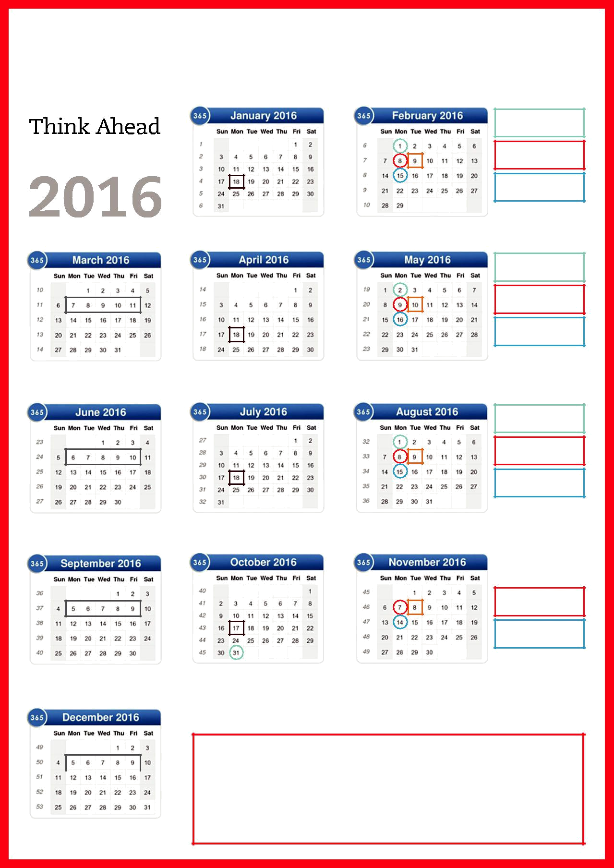
 Key exam dates

Standard Deadline

(March 2016)

Late Deadline

(March 2016)

Early Deadline

(June 2016)

December 2015 Results Release |  | September 2016 Early Entry Opens

Standard Deadline

(June 2016)

Late Deadline

(June 2016)

Early Deadline

(September 2016)

March 2016 Exam Session |  | March 2016 Results Release |  | December 2016 Early Entry Opens

Standard Deadline

(September 2016)

Late Deadline (September 2016)

Early Deadline (December 2016)

June 2016 Exam Session |  | June 2016 Results Release |  | March 2017 Early Entry Opens

Late Deadline (December 2016)

Early Deadline

(March 2017)

September 2016 Exam Session |  | September 2016 Results Release |  | June 2017 Early Entry Opens
 |  | Standard Deadline (Dec 2016)

The benefits of ACCA’s new exam model

 |  | 1. |  | We will still offer early/standard/late exam entry pricing windows.
2. |  |  |  | Students can enter for two exam sessions at the same time – so they can pay the
 |  |  |  | cheapest exam fees for both sessions.
3. |  |  |  | Students can resit exams within three months – entry for the next exam session
 |  |  |  | does not close until after results have been issued for the previous exam session.
December 2016 Exam Session

